
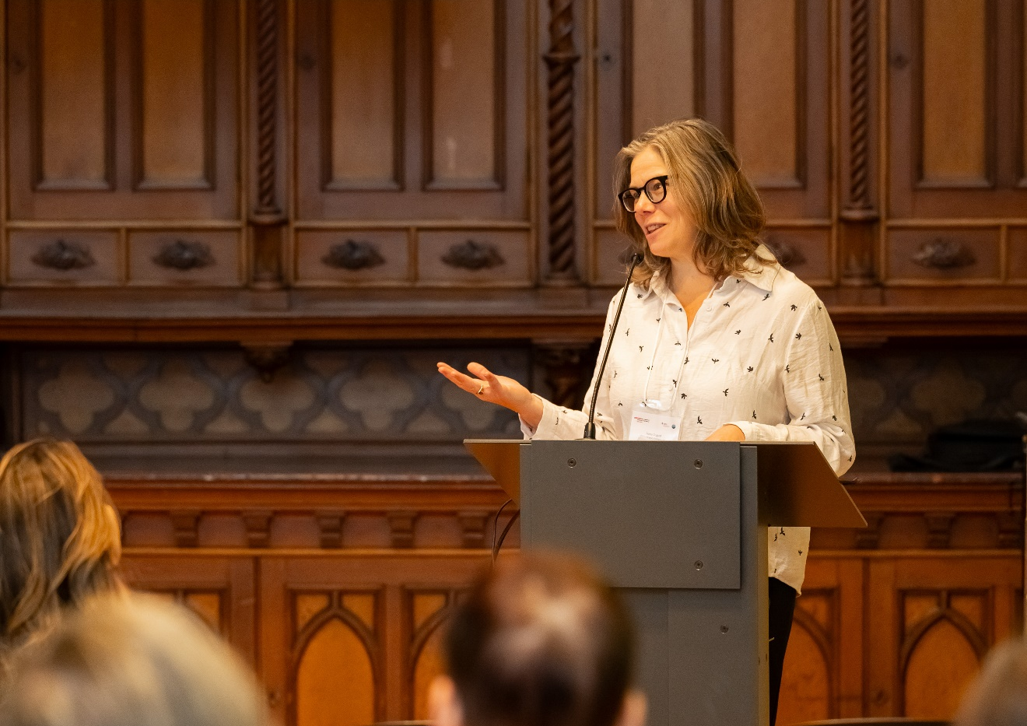
CEARC Newsletter 2026

EDI Beyond the Numbers: Rethinking How We Learn, Work and Lead
Fiona Duguid

The Multidisciplinary Colloquium “Equity, Diversity and Inclusion (EDI) beyond the numbers,” co-ordinated by the Chaire de coopération Desjardins–Guy Bernier (ESG UQAM), CIRIEC Canada and CEARC, SMU, brought together researchers and students to explore EDI as a truly cross-cutting theme. The event highlighted how EDI spans disciplines and methods, from quantifying and evaluating impacts, to understanding underlying causes and consequences, to examining the human experience of inclusion in a rapidly changing technological and geopolitical context.
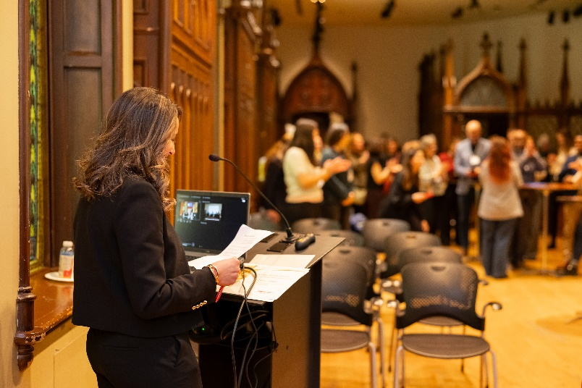
The morning focused on PhD student experiences, engagement opportunities, and the evolving labour landscape awaiting graduating students. Later sessions examined what EDI means in practice, how it is represented in different industries and organizational forms, including co-operatives and mutuals, ways to measure EDI, and how accounting practices can better integrate EDI considerations.
Designed to be inclusive and welcoming of diverse perspectives, the colloquium created space for rich, interdisciplinary dialogue.

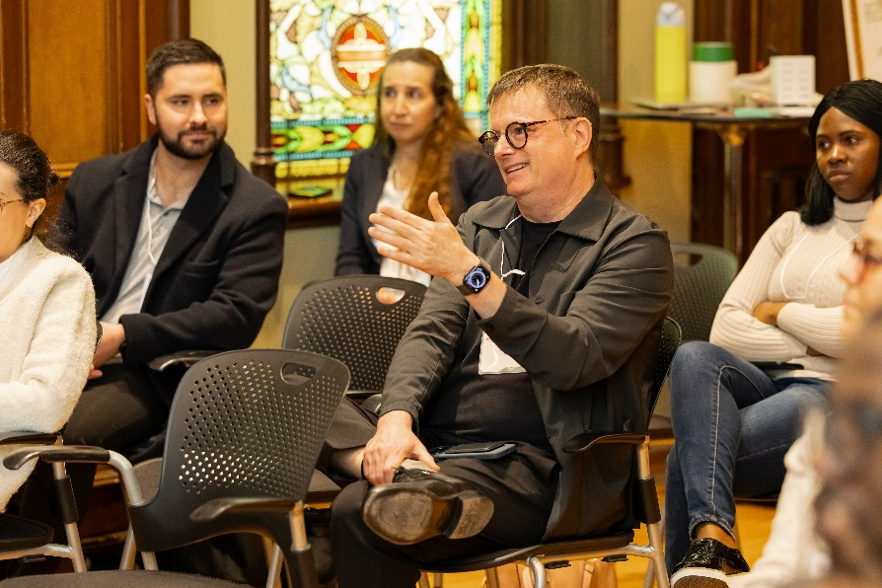
This was supported by excellent food and informal exchanges. A reception honouring Michel Séguin, retiring full professor in human resources and organization at UQAM’s School of Management and co-director of the Guy-Bernier Chair in Cooperative Business, was enjoyed by all.
His career has been dedicated to research and teaching on co-operative enterprises, the ethical dimensions of management, and organizational governance.
EDI is not just something to measure, but needs to be embedded into how we learn, work and lead together.

